Appendix 1

Growing Inclusive Wellbeing - School Wellbeing Framework

School Vision:

School Values:

Wellbeing Definition:

Model: ‘Growing Inclusive Wellbeing’  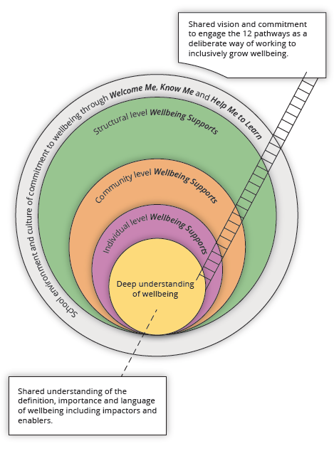 | 12 Key Pathways to Embedding School Community Focus on Wellbeing.  1. Expert school leadership  2. Strategic visioning  3. Quality teaching and learning  4. S supportive, caring, and inclusive school community  5. A safe learning environment  6. Social and emotional competencies  7. A sense of meaning and purpose  8. Using, monitoring, and evidencing strengths-based approaches  9. Strategies encouraging a healthy lifestyle  10. Programs to develop pro-social values  11. Family and community partnership  12. Spirituality
Carter, S. & Andersen, C. (2018). Resource for Growing Inclusive Wellbeing. Toowoomba, Australia: University of Southern Queensland.

