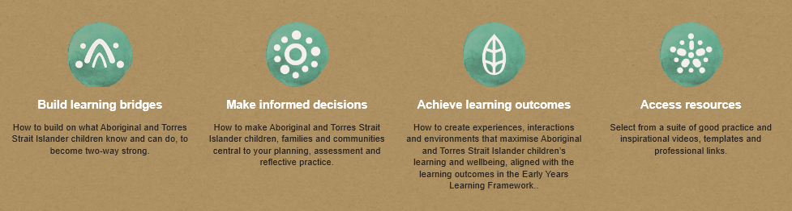

**The Western Downs Regional** **Council** Library, as part of the First 5 Forever Program has installed its first educational ‘storywalk’ in the Chinchilla Botanical Parklands. The first story installation is ‘SillyBirds’ an indigenous story written by Gregg Dreise. This provides the community with a unique outdoor reading experience and opens conversation around other local Indigenous stories.

The WDRC also offers school holiday programs at the local Lapunyah Art Gallery inviting children to learn first-hand from local and visiting aboriginal artists. One artist is local man, Anthony ‘Boy’ Turnbull. Mr Turnbull sees his painting as a way to share his culture and bridge the gap between cultures, by explaining why he paints what he does and what it means to him as an Aboriginal man.

**More information can be found at www.wdrc.qld.gov.au**

**Tracks Indigenous Services**, is a local service, working to encourage and enable positive working partnerships between Indigenous Australians and enterprises, working toward closing the gap and creating opportunities for local Indigenous people to participate in the workforce. Tracks specialises in cultural awareness, cross-cultural communication, Indigenous engagement strategies and cultural heritage assisting the community to develop successful and sustainable relationships with Indigenous groups and individuals. https://www.tracksis.com.au/

**Community Connections**

**To find Local Elders or representatives in your region to perform Welcome to Country or Acknowledgement of Traditional Owners, Contact 13 QGOV (13 74 68)**

**Professional Development-**

**Foundations for Success** assists early childhood educators to plan, deliver and reflect on programs focussing on children’s learning. This website provides culturally appropriate support around the Early Years Learning Framework (EYLF) and assists educators to implement holistic programs, achieve critical elements within the National Quality Standard and deliver effective learning programs for Aboriginal and Torres Strait Islander children (Queensland Department of Education, n.d).

Figure 1-https://www.foundationsforsuccess.qld.edu.au/ used under CC-BY licence