We gather today in this special place continue our learning journey together.
We acknowledge Aboriginal and Torres Strait Islander people as the traditional custodians of the land upon which we meet.
We pay our respects to the Elders of the past, present and future and acknowledge their spiritual connection to the country.
Source: Welcome to Country & Acknowledgement of Country - Creative Spirits, retrieved from https://www.creativespirits.info/aboriginalculture/spirituality/welcome-to-country-acknowledgement-of-country

Acknowledgement of Country

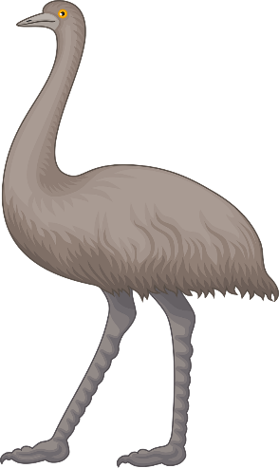
Click on the link to access the Innovative Reconciliation Action Plan https://www.acecqa.gov.au/sites/default/files/2019-02/ACECQA_RAP.pdf

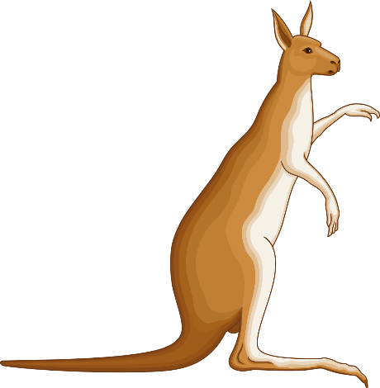

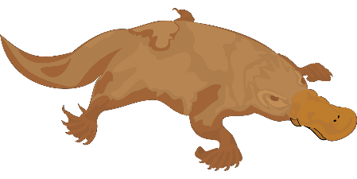
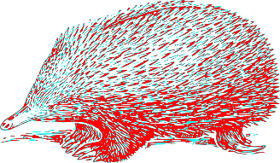
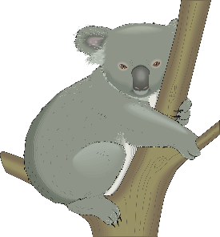

Kangaroo = Muni
Koala = Borobi
Emu= Murun
Platypus = Wajin
Echidna = Buneen
Please click on the link to locate the proud custodian owners of the land. This particular map was ‘developed along with the Encylopedia of Aboriginal Australia as part of a research project’ (1996).
https://aiatsis.gov.au/explore/articles/aiatsis-map-indigenous-australia

NAIDOC week - https://www.naidoc.org.au/get-involved/2020-theme

Ngurambangga Yanhanha -Walking on Country is a beautiful song written and sang by Sharon Lindh. This song was designed to encourage ‘all people to explore and connect to country’ (DEPT of Education, 2020)
https://www.earlyyearscount.earlychildhood.qld.gov.au/age-spaces/sharron/

Australian Children’s Education and Care Quality Authority [ACECQA] (2017). Guide to the National Quality Standard. Sydney: ACECQA. Accessed 10/08/2020 from
https://www.acecqa.gov.au/sites/default/files/2018 02/belonging_being_and_becoming_the_early_years_learning_framework_for_australia.pdf
NAIDOC (National Aborigines and Islanders Day Observance Committee) is celebrated on a yearly basis since the 1920’s and goes for a week. The website below provides a range of resources to increase awareness in the wider community concerning the status and treatment of the Aboriginal and Torres Strait Islander Australians (Australian Government, 2020). https://www.naidoc.org.au/get-involved/2020-theme

Australian Institute of Aboriginal and Torres Strait Islander Studies [AIATSIS] (2020). AIATSIS map of Indigenous Australia. Accessed 10/08/2020 from

