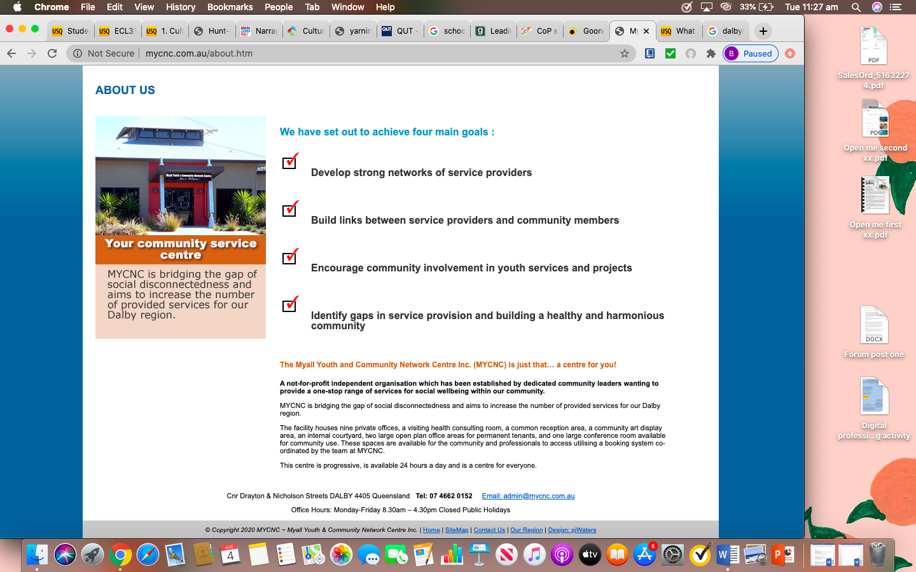

*Goondir Health Services*

Goondir Health Services is an Aboriginal Community Controlled Health Service located in the township of Dalby. Programs and resources offered at Goondir are unique and tailored to address the needs of Aboriginal and Torres Strait Islander clients.

To access their homepage, follow this link; <https://www.goondir.org.au/>

*Myall Youth and Community Network Centre Inc.*

The Myall Youth and Community Network Centre Inc. (MYCNC) is an independent organisation which has been developed by community leaders wanting to provide a range of services for social wellbeing within the region of Dalby (Drayton & Streets, 2020).

A bit about Dalby…

* Current population of 12,719 with 7.0% being Aboriginal and/or Torres Strait Islander people
* The community consists of;

-3 Early Learning Centres

-2 Kindergartens

-3 Primary Schools

-2 High Schools

What is offered?

* Social and Emotional Wellbeing
* Transport
* Big Buddy Program
* Wandir Gunde Playgroup
* General Practice
* 715 Health Checks
* Dental Care
* Integrated Team Care
* Mobile Health Promotion Van

MYCNC Goals

Services;

* Multicultural Australia
* Youth Justice Conferencing
* Child Safety
* Goolburri Family Wellbeing
* Youth in Search Support Groups
* Dalby District Domestic Family Violence Action Group

To access their homepage, follow this link; <http://www.mycnc.com.au/default.htm>

Local Groups in Dalby

**Establishing a community of practice**

*Looking specifically at Dalby, Queensland*

*The best education systems in the world are highly networked. In other words, these systems have principles and educators who are well connected to their community through active partnerships. To establish a community of practice and support children from diverse backgrounds, professional relationships can be fostered with the following Dalby local groups, which in turn will allow for the sharing of resources and knowledge.*