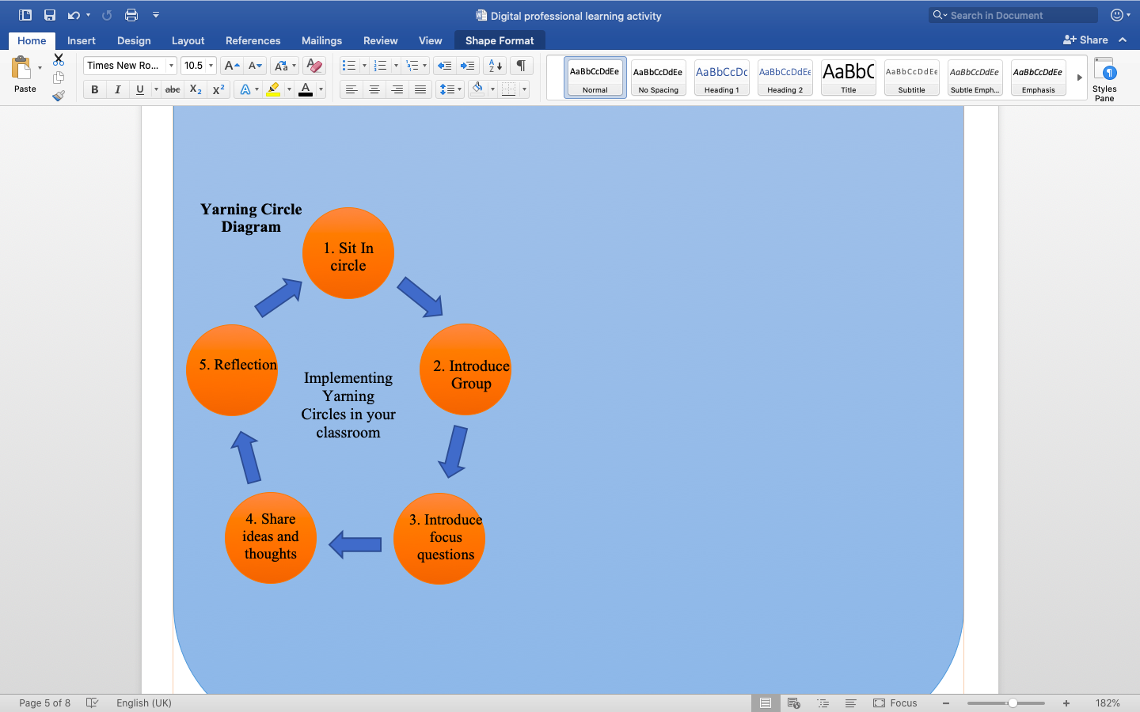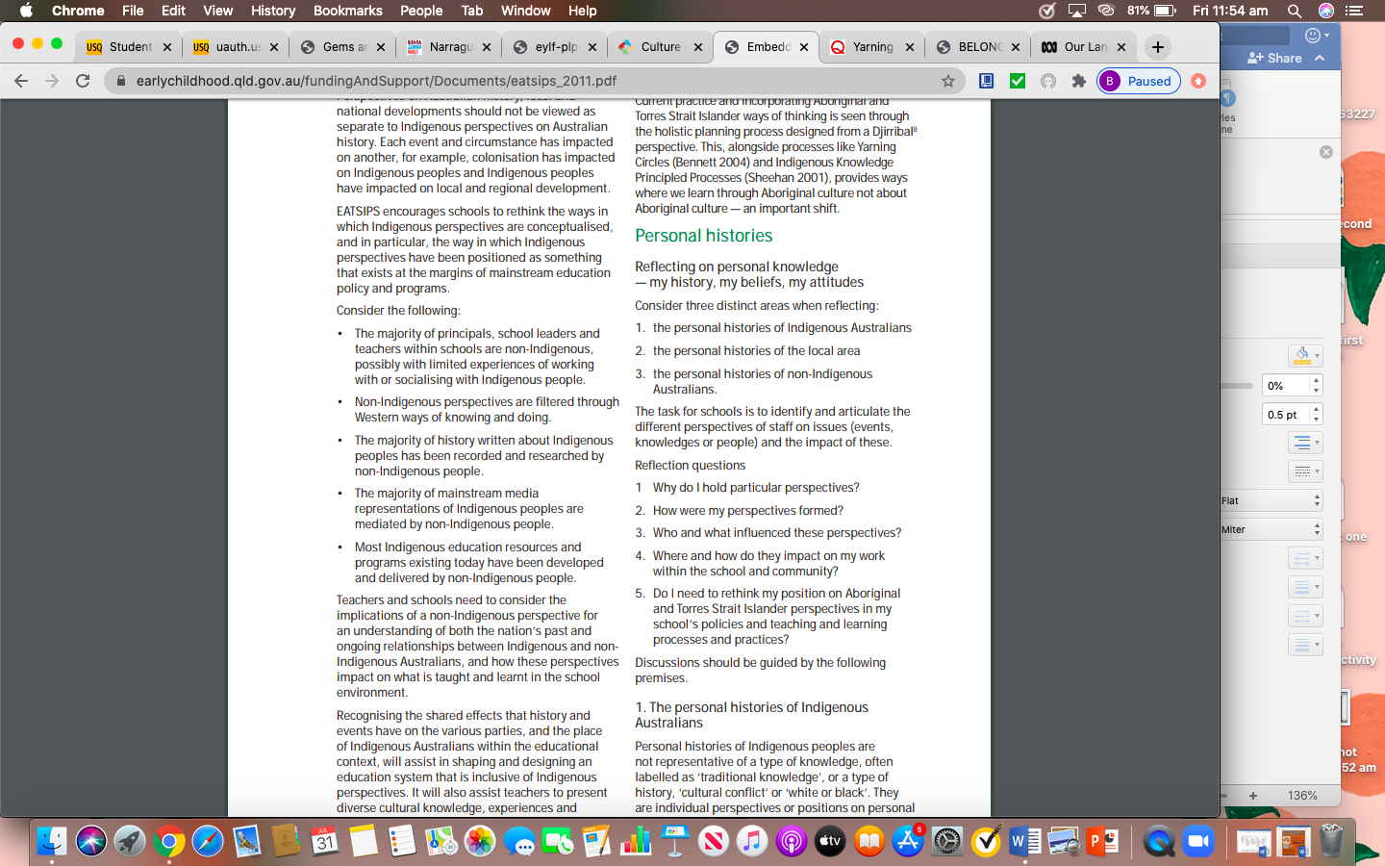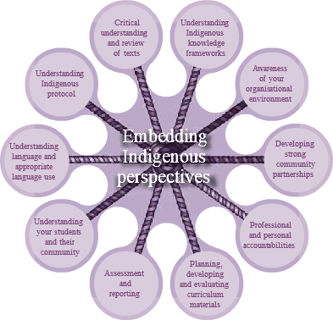

Section three of the guide also withholds significant information, where a set of considerations are provided for the reader.

When looking at the guide, focus specifically on section five where you will find a framework; ‘Embedding Indigenous Perspective’.

With more than 455 028 Aboriginal and Torres Strait Islander people in Australia (Queensland Government, 2011), it is clear to see that educators share an important role in embedding their perspectives in schools. To support educators in doing so, the Queensland Government (2011) has developed a document that can be accessed in both hard copy and online; Embedding Aboriginal and Torres Strait Islander Perspectives in Schools [EATSIPS].

**The guide can be easily accessed by using the below link;** <https://earlychildhood.qld.gov.au/fundingAndSupport/Documents/eatsips_2011.pdf>.

Before sharing Indigenous culture within the classroom, it is suggested that educators read through this guide as it provides a concrete understanding of and respect for Australia’s Indigenous peoples, especially in relation to their personal histories, beliefs and values, languages and lifestyles.

Image By: Queensland Government

**How this information from the guide can be used to construct a classroom activity**

-Use the different points on the ‘Embedding Indigenous Perspectives’ framework to ask yourself questions. For example, the ‘understanding your students and their community’ strand may get you thinking about what Aboriginal and Torres Strait Islander resources will be required to support classroom leaning.

-Ensure that you are not disregarding the considerations. For example, what recourse could be used in the classroom that weren’t developed by non-Indigenous people?

**Yarning Circles**

After considering the above, Yarning Circles have been suggested as a process for educators to use within the classroom when introducing authentic Indigenous ways of working.

The use of a Yarning Circle is an important practice within Indigenous culture, where issues are discussed in an inclusive and collaborative matter. There are many different ways of thinking about, talking about, and using yarning circles. In fact, a ‘Yarning Circle Diagram’ has been constructed by the Queensland Curriculum and Assessment Authority (2020).It is recommended that educatorswho are wanting to use Yarning Circles within their curriculum, follow this diagram to guide the process.

*Indigenous content is a requirement of the education curriculum that teachers often struggle to incorporate. Jane Marshall, a lead teacher at Canberra’s Gold Creek Early Childhood School, supports this statement as she believes that a lot of educators want to embed Indigenous perspectives into their classroom, but at times are overwhelmed with how to do it and where to source quality materials (Kinniment, 2019). In order to assist educators who may be facing this problem, ‘Learning how to share Indigenous culture within your classroom’ has been developed.*

**Learning how to share Indigenous culture within your classroom**