**What? How to** Build Relationships with Indigenous Peoples. Know the key considerations to keep in mind when nurturing relationships with Indigenous Peoples.

**Why?** Assist educators to respectfully foster positive relationships with Indigenous children in the classroom, their families and the wider community. Get to know the families so you can source local/ relevant resources.

**Where?** Link - [ictinc](https://www.ictinc.ca/blog/7-tips-on-building-relationships-with-indigenous-peoples)

**What?** Aboriginal Australia Map is an attempt to represent all the language, tribal or nation groups of the Indigenous peoples of Australia

**Why?** Inform educators on local tribes. You need to know who the local tribes are before you find local resources.

**Where? Link-** [Aboriginal Australia](http://nationalunitygovernment.org/pdf/aboriginal-australia-map.pdf)

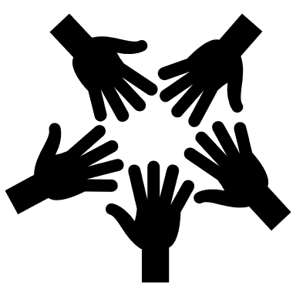

Educators guide to sourcing local Indigenous Cultural Resources

**What?** Yulunga Traditional Indigenous Games is a selection of games and activities from Aboriginal and Torres Strait Islander societies all around Australia.

**Why?** Educators can usethegames that are local to the school/ Indigenous Community area.

**Where?** Link - [Yulunga](https://www.sportaus.gov.au/yulunga)

**What?** Dreaming Stories is a resource that includes authentic dreaming story materials, explains where the story originates from and unpacks the relevant key learning areas for children.

**Why?** Dreaming Storiesplay an important part in the cultural heritage of Aboriginal and Torres Strait Islander peoples because Indigenous values, responsibilities and spiritual beliefs are woven into the stories. Educators can use these stories in the classroom.

**Where?** Link - [Dreaming Stories](https://files.eric.ed.gov/fulltext/ED497531.pdf)