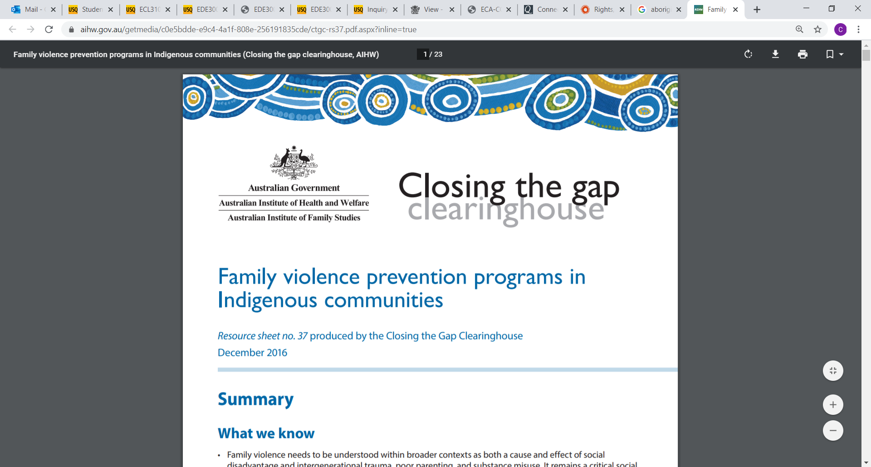

**(Pixabay)**

* Begin all meetings and important events, including meetings with children with an Acknowledgement of Country
* For events with significant meaning, consult with Local Elders groups about a Welcome to Country
* Attend relevant training and gain education to feel confident in passing on knowledge about Indigenous cultures to children in a meaningful and informed way
* Consult with local Lands Council, Indigenous cultural centres etc.
* Access resources from organisations such as Indigenous Professional Support Unit (IPSU), and the Secretariat of National Aboriginal and Islander Child Care (SNAICC)
* Invite Indigenous performers and artists into the service and hold workshops for children and families
* Invite Elders or community representatives into the service to share their own cultural knowledge  
    
  (Bamford & Maguire, 2012; Australians Together, 2020)
* Understand that Indigenous peoples’ are entitled to respect for their culture
* Respect the rights of Indigenous peoples’ in relation to their knowledge, ideas, cultural expression and materials, and their rights to maintain secrecy of knowledge and practices
* When planning activities involving the production of, or a replica of Indigenous cultural expression, consultation with the Traditional Owners of the land on which the service stands must occur
* The planned activities must not damage Indigenous cultural integrity in any way
* Indigenous Cultural and Intellectual Property (ICIP) rights must always be respected
* Seek to understand Indigenous culture to assist in dispelling stereotypes and myths about Indigenous peoples  
    
  (Australian Institute of Aboriginal and Torres Strait Islander Studies [AIATSIS], 2019; Victoria State Government Education and Training, 2020)

**Guidelines for embedding Indigenous perspectives in early childhood services –**

*Indigenous culture is highly valued and significant in Australia, and so it is important that educators help children understand the history, culture and lives of the Indigenous community. This resource provides information and guidelines that should be considered when sharing and embedding Indigenous culture and perspectives within programming and planning in early childhood.*