Teachers’ resource

This resource offers teachers ways to make links with their local Indigenous community. Each website has been evaluated.

Acknowledgement of Country
I respectfully acknowledge the Yugambeh People, the traditional owners of the land in which we meet and pay my respect to their elders past and present, and all Aboriginal and Torres

Embedding Aboriginal and Torres Strait Islander Perspectives in schools
This excellent resource is worth downloading for any teacher.

Aboriginal and Torres Strait Islander perspectives from Queensland Curriculum and Assessment Authority (QCAA).
There are four sections that will lead to very distinct and crucial information to support teachers:
- Policies
- Research
- Resources

AIATSIS
This comprehensive link has a multitude of resources. By clicking on each of the headings provided:
- History
- Culture
- People
- Rights
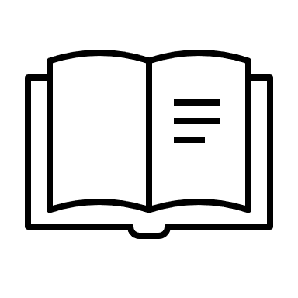
Much will be discovered that will assist teachers for any stage level. Exploring the website will give significant and valuable information on areas such as, Land Rights, Mabo, Freedom Ride, and important Indigenous history and change makers.

Indigenous Literacy Foundation
From the home page there are many links to resources including wonderful books.

State Library of Queensland
State Library of Queensland provides exhibitions on dreaming stories and resources on Aboriginal and Torres Strait Islander languages.

3Rs: Respect, Relationships, Reconciliation
This website takes a more specific approach for teachers and students. It offers three modules consisting of:
- Know yourself
- Know your students
- Know what you teach
Under Faculty Guide is worth exploring as are the ‘Teacher education resources’ which deserves serious exploration as it provides a wealth of information such as; culture, history, inclusion, identity, Indigenous perspectives, reconciliation, pedagogy, Australian curriculum, parent engagement, statistics, professional experience, professional knowledge plus many more.
There is also an excellent section of ‘Working with IEWs as teacher partner. IEWs are Indigenous Education Workers. A partnership with your IEWs is both professionally and personally rewarding as they are as their knowledge and expertise is valuable.
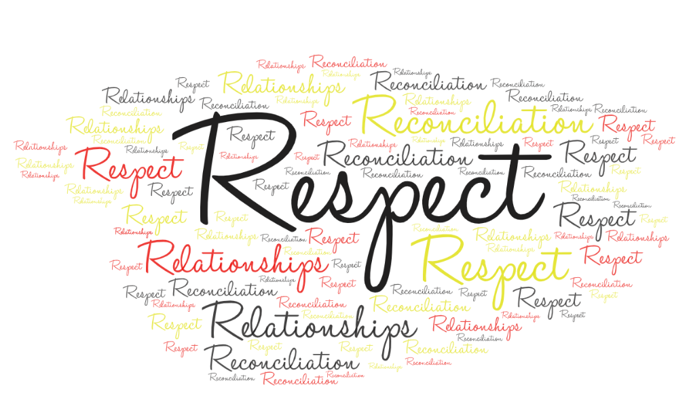

Narragunnawali
Three sections that will offer many resources.
- Reconciliation Action Plans
- Professional Learning
- Curriculum Resources
Anyone can subscribe to this site for free which opens more resources for teachers.

Sources
Gold Coast City Council. (2020). Indigenous Protocol Retrieved 05 August, from https://www.goldcoast.qld.gov.au/thegoldcoast/indigenous-protocol-29648.html#:~:text=The%20City%20has%20endorsed%20the,Strait%20Islander%20Peoples%20here%20today
Images from clip art and word cloud.

