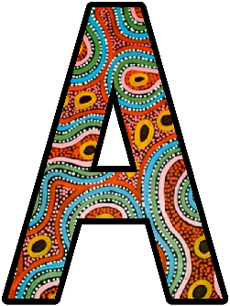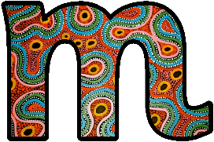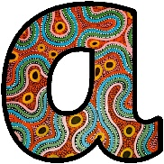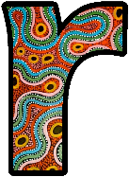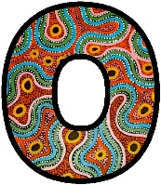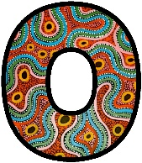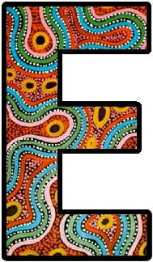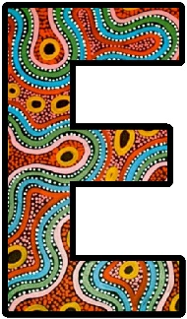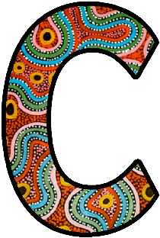
Amaroo ECC take inspiration from the local acknowledged traditional owners of the land, the Jarowair and Giabal peoples whose ancestors came to Australia over 60,000 years ago and managed to live all over Australia in a sustainable manner, without depleting or polluting our natural resources.
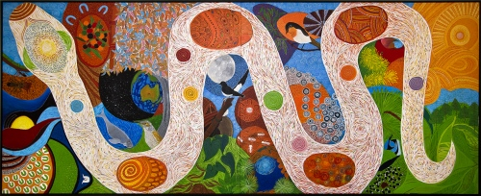
Indigenous perspectives by Amaroo ECC, 2019 used under CC-By licence.

Parbay (Kindergarten)
Parbay means ‘Little Murri One’.
This day program connects Kindergarten-age students with Aboriginal culture on Jarowair country. Students will:
- engage in a bush exploration following tracks of the goanna and the kangaroo, identifying local animals
- make use of a local Indigenous artist’s beautiful mural and a local stonemason’s magnificent rock carvings
- conduct a treasure hunt matching local fauna and flora.
Students will also be taught an Indigenous dance and use Indigenous weapons.

Plan your visit
https://amarooeec.eq.edu.au/planning-your-visit/booking-information

