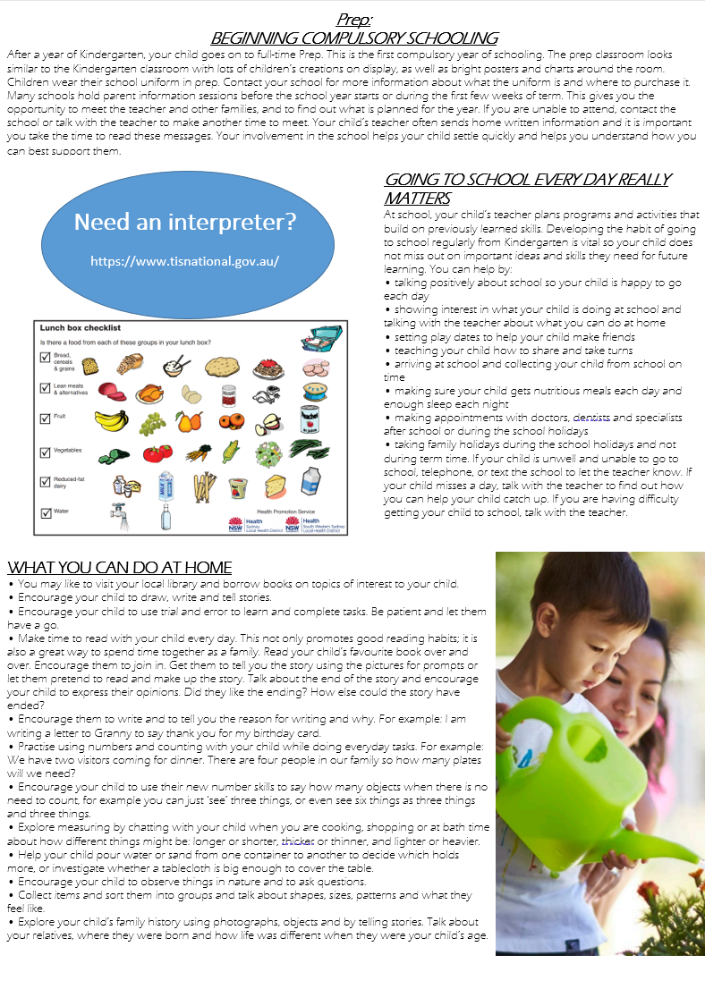

**GOING TO SCHOOL EVERY DAY REALLY MATTERS**

At school, your child’s teacher plans programs and activities that build on previously learned skills. Developing the habit of going to school regularly from Kindergarten is vital so your child does not miss out on important ideas and skills they need for future learning. you can help by:

* Talking positively about school so your child is happy to go each day
* Showing interest in what your child is doing at school and talking with the teacher about what you can do at home
* Setting play dates to help your child make friends
* Teaching your child how to share and take turns
* Arriving at school and collecting your child from school on time
* Making sure your child gets nutritious meals each day and enough sleep each night
* Making appointments with doctors, dentists and specialists after school or during school holidays
* Taking family holidays during the school holidays and not during term time. If your child is unwell and unable to attend school, telephone or text the school to let the teacher know. If your child misses a day, talk with the teacher to find out how you can help your child catch up. If you are having difficulty getting your child to school talk with the teacher

**WHAT YOU CAN DO AT HOME**

* You may like to visit your local library and borrow books on topics of interest to your child.
* Encourage your child to draw, write and tell stories.
* Encourage your child to use trial and error to learn and complete tasks. Be patient and let them have a go.
* Make time to read with your child every day. This not only promotes good reading habits; it is also a great way to spend time together as a family. Read your child’s favourite book over and over. Encourage them to join in. Get them to tell you the story to using the pictures for prompts or let them pretend to read and make up the story. Talk about the end of the story and encourage your child to express their opinions. Did they like the ending? How else could the story have ended?
* Encourage them to write and tell them the reason for writing and why. For example: I am writing a letter to Granny to say thank you for my birthday card.
* Practise using numbers and counting with your child while doing everyday tasks. For example: We have two visitors coming for dinner. There are four people in our family so how many plates will we need?
* Encourage your child to use their new number skills to say how many objects when there is no need to count, for example you can just ‘see’ three things, or even sic things as three things and three things.
* Explore measuring by chatting with your child when you are cooking, shopping, or at bath time about how different things might be shorter, longer or longer, thicker or thinner and lighter or heavier.
* Help your child pour water or sand from one container to another to decide which holds more, or investigate whether a tablecloth is big enough to cover the table.
* Encourage your child to observe things in nature and ask questions.
* Collect items and sort them into groups and talk about shapes, sizes, patterns and what they feel like.
* Explore your child’s family history using photographs, objects and by telling stories. Talk about your relatives, where they were born and how life was different when they were your child’s age.

**Need an interpreter?**

https://www.tisnational.gov.au/

**PREP:**

**BEGINNING COMPULSORY SCHOOL**

After a year of Kindergarten your child goes on to full-time prep. This is the first compulsory year of schooling. The prep classroom looks similar to the Kindergarten classroom with lots of children’s creations on display, as well as posters and charts about the room. Children wear their school uniform in prep. Contact your school for more information about what the uniform is and where to purchase it.

Many schools hold parent information sessions before the school year starts or during the first few weeks of term. This gives you the opportunity to meet the teacher and other families, and to find out what is planned for the year. If you are unable to attend, contact the school or talk with the teacher to make another time to meet. Your child’s teacher often send home written information and it is important you take the time to read these messages. Your involvement in the school helps your child settle quickly and helps you understand how you can best support them.