The exploratory factor analysis of a social support questionnaire was conducted using the maximum likelihood method of extraction, with the oblique rotation method being ProMax.. The reasoning for this is that the items would likely be related conceptually. Communalities ranged from .31 to .70 (see Table 1.). For easy of interpretation, factor loadings (see Table 2.) are from the pattern matrix, though similar loadings were found in the structure matrix. Eigenvalues of ≥1 would be used to interpret the number of factors in the data set.

Table 1.
Communalities for Exploratory Factor Analysis of a Social Support Questionnaire (N = 367).
Item No. | Items | Communalities
1 | If I were sick, I could easily find someone to help me with my daily chores. | .70
2 | There is someone I can turn to for advice about handling problems with my family. | .37
3 | If I decide one afternoon that I would like to go to a movie that evening, I could easily find someone to go with me. | .48
4 | When I need suggestions on how to deal with a personal problem, I know someone I can turn to. | .42
5 | If I wanted to have lunch with someone, I could easily find someone to join me | .46
6 | If I was stranded 15km from home, there is someone I could call who would come and get me. | .48
7 | If I were sick, I could easily find someone on Facebook to help me with my daily chores. | .44
8 | There is someone on Facebook I can turn to for advice about handling problems with my family. | .36
9 | If I decide one afternoon that I would like to go to a movie that evening, I could easily find someone on Facebook to go with me. | .31
10 | When I need suggestions on how to deal with a personal problem, I know someone on Facebook I can turn to. | .36
11 | If I wanted to have lunch with someone on Facebook, I could easily find someone to join me. | .31
12 | If I was stranded 15km from home, there is someone on Facebook I could call who would come and get me. | .35

Table 2.
Pattern Factor Loadings for Exploratory Factor Analysis of a Social Support Questionnaire (N = 367).
 |  | Factor
Item No. | Items | 1 | 2
1 | If I were sick, I could easily find someone to help me with my daily chores. | -.01 | .55
2 | There is someone I can turn to for advice about handling problems with my family. | -.04 | .81
3 | If I decide one afternoon that I would like to go to a movie that evening, I could easily find someone to go with me. | .01 | .68
4 | When I need suggestions on how to deal with a personal problem, I know someone I can turn to. | -.05 | .79
5 | If I wanted to have lunch with someone, I could easily find someone to join me | .14 | .65
6 | If I was stranded 15km from home, there is someone I could call who would come and get me. | -.04 | .74
7 | If I were sick, I could easily find someone on Facebook to help me with my daily chores. | .73 | .03
8 | There is someone on Facebook I can turn to for advice about handling problems with my family. | .78 | .03
9 | If I decide one afternoon that I would like to go to a movie that evening, I could easily find someone on Facebook to go with me. | .84 | -.03
10 | When I need suggestions on how to deal with a personal problem, I know someone on Facebook I can turn to. | .83 | -.05
11 | If I wanted to have lunch with someone on Facebook, I could easily find someone to join me. | .82 | .02
12 | If I was stranded 15km from home, there is someone on Facebook I could call who would come and get me. | .80 | .02
 | Eigenvalues | 5.25 | 1.39
 | % of Variance | 32.5 | 25.5
Note. Factor loadings are in boldface. Extraction Method: Maximum Likelihood. Rotation Method: Promax Rotation.

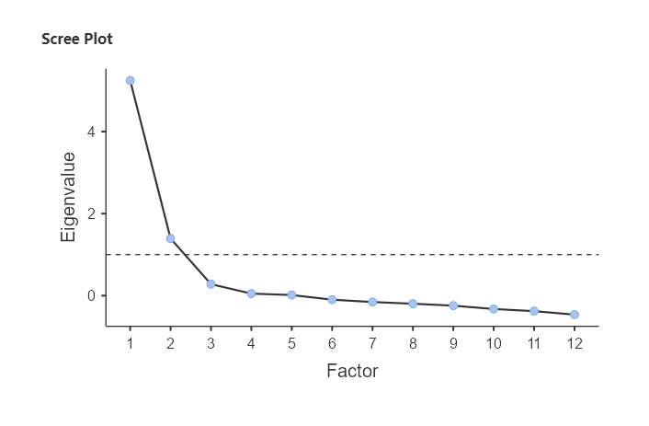

Figure 1. Scree Plot for Exploratory Factor Analysis of a Social Support Questionnaire (N = 367).
Loading Patterns
As can be seen in Table 2. and Figure 1., the results showed that there two factors on to which items were loading, explaining 58.0% of total variance.
Factor 1 (Face-to-face Social Support)
Factor 1 contained 4 items (items 1, 2, 3, 4, 5, and 6), which appeared to measure social support via face-to-face means (e.g. “There is someone I can turn to for advice about handling problems with my family.”) and was named Face-to-face Social Support. A follow-up reliability analysis found factor 1 to have good internal consistency (α = .86).
Factor 2 (Facebook Social Support)
Factor 1 contained 4 items (items 7, 8, 9, 10, 11, and 12), which appeared to measure social support using Facebook (e.g. “If I decide one afternoon that I would like to go to a movie that evening, I could easily find someone on Facebook to go with me.”) and was named Facebook Social Support. A follow-up reliability analysis found factor 2 to have excellent internal consistency (α = .92).
Factor Correlations
Table 3.
Factor Correlations for Exploratory Factor Analysis of a Social Support Questionnaire (N = 367).
Factor | 1 | 2
1 (Face-to-face Social Support) | -
2 (Facebook Social Support) | -.53 | -

