Growing Inclusive Wellbeing - School Wellbeing Framework

School Vision:

School Values:

Wellbeing Definition:

Model: ‘Growing Inclusive Wellbeing’  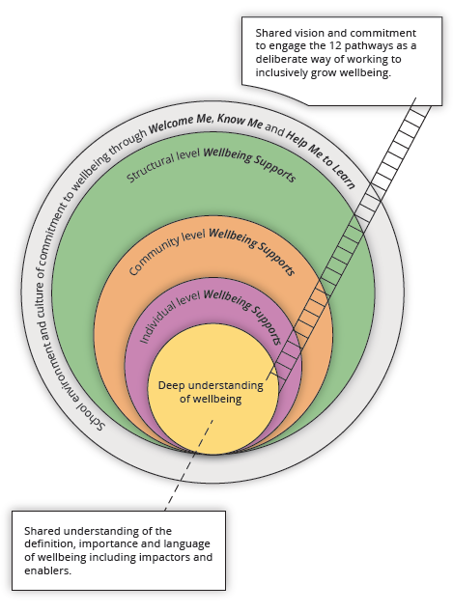 | 12 key pathways to embedding an education wide focus on wellbeing  1. expert school leadership  2. strategic visioning  3. quality teaching and learning  4. a supportive, caring and inclusive school community  5. a safe learning environment  6. social and emotional competencies  7. a sense of meaning and purpose  8. using, monitoring and evidencing strengths-based approaches  9. strategies encouraging a healthy lifestyle  10. programs to develop pro-social values  11. family and community partnership  12. spirituality
Carter, S. & Andersen, C. (2018). Resource for Growing Inclusive Wellbeing. Toowoomba, Australia: University of Southern Queensland.

