Acknowledgement to Country
Here is the land,
Here is the sky,
Here are my friends and here am I.
We thank you [name of group] people for the land on which we learn and play.
Hands up, hands down,
We’re on [name of group] ground (A. Stokes personal communication, December 10, 2019).
Please note: you are able to find your Indigenous language, social or nation group from The AIATSIS map of Indigenous Australia https://aiatsis.gov.au/explore/articles/aiatsis-map-indigenous-australia

Please follow this link to watch a small clip on how children can sing the song coupled with actions https://youtu.be/DAd6qRAA3jw (Matthews, 2019).
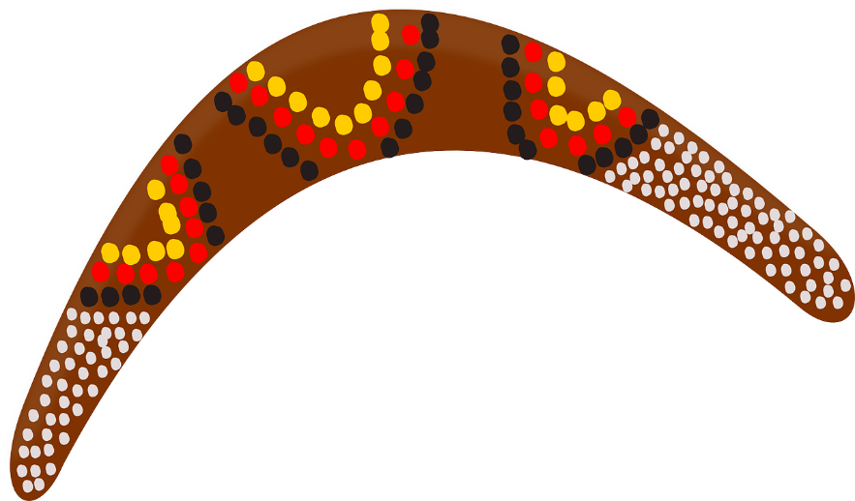

Image: OpenClipart-Vectors, Boomerang, used under CC-BY

Incorporating Technology
The resource can be used to embed technology into the learning experience. The children can use class iPads or any filming devices to film each other singing the song (please note, guardian permission will be required). Once recorded various editing software can be used to create a mini film clip. The children can be a part of the editing process. Once the clip has been complied, it can be used to welcome guests to ceremonies held on the land. A projector can be used to display the presentation. Please see the following link for a list of free accessible video editing software programs (Clideo, 2019). https://clideo.com/resources/software/free-video-editing-software

